**1.** **Introduction** :

In our fast-moving world today, road safety is more important than ever before. The number of people using cars, traveling long distances, and spending more hours on the road, especially commercial drivers, has increased a lot. This has raised the chances of accidents due to tiredness. One serious and often ignored cause of accidents is **drowsy driving.** This happens when drivers become very tired, lose their focus, or briefly fall asleep at the wheel. These moments of inattention can lead to severe accidents, causing injuries or even fatalities.

Recent statistics reveal that **nearly 40% of highway accidents in India are due to driver fatigue.** This alarming number highlights the magnitude of the issue. Long, boring trips and lack of sleep are common, particularly among truck drivers, night-shift workers, and individuals on long road journeys. Unlike driving under the influence or speeding, tiredness is difficult to identify without special tools, making it a hidden danger on the roads. The issue is similarly serious globally. In the United States, the AAA Foundation for Traffic Safety reported that about 18% of fatal crashes are related to drowsy driving. These figures indicate an urgent need for smart and timely solutions to alert drivers before accidents occur.

To tackle this problem, we developed the **"Sleep Detection and Alert System for Drivers Using AI and IoT."** This system continuously monitors the driver’s face—particularly their eyes—using live video and artificial intelligence (AI). It detects signs of weariness based on the **Eye Aspect Ratio (EAR),** which lowers when someone blinks slowly or keeps their eyes closed for a period. A camera located near the driver's seat continuously observes the face, and when the AI identifies signs of fatigue, it promptly triggers an alert.

The alert includes **a buzzer for sound warnings,** flashing **LED** lights for visual signals, and a screen that displays warning messages, alerting both the driver and nearby vehicles. This immediate warning system helps in waking up the driver, preventing accidents. At the core of this system is the **ESP32-CAM module,** equipped with **a 2MP camera** and Wi-Fi capability. This device captures the video stream and sends it to a Python-based program that analyzes the face for drowsiness. Then, it sends a command back to the ESP32 to activate the alert components.

The use **of IoT (Internet of Things)** boosts the system's effectiveness by enabling communication with other devices. The ESP32 can send messages to web servers or mobile apps, allowing remote monitoring and logging of alerts. This feature is particularly helpful in fleet management, where supervisors can be notified if a driver is showing signs of fatigue. The system also logs the driver’s status, which is valuable for analyzing patterns over time.

What makes this system especially promising is its cost-effectiveness and scalability. It uses affordable, widely available components and does not need expensive computing equipment. By combining **AI for smart detection** and IoT for efficient communication, this project provides a robust solution for enhancing road safety.

In conclusion, our project offers a practical and efficient method to address drowsy driving. By detecting fatigue early and issuing timely warnings, it significantly reduces the risk of accidents. Whether implemented in personal vehicles or commercial fleets, this system has the potential to **save lives, prevent property damage, and encourage more responsible driving across the nation.**

**2. Literature Survey :**

In today's demanding world, fatigue-related accidents have become increasingly worrying, mainly in key industries such as transportation, logistics, health care, and manufacturing. In India, only transport authorities say poor driving is responsible for around 40% of all rural road accidents, often happening when drivers doze off**,** especially late at night. A chilling example is the **Samruddhi Expressway** in Maharashtra, where many fatal crashes between midnight and 3 a.m. were directly linked to drowsiness. According to the AAA Foundation for Traffic Safety in the USA, there were about 30,000 deaths from drowsy driving between 2017 and 2021. This means drowsy driving was responsible for roughly **18% of all traffic accident deaths.**

To address this critical challenge, we have developed a "Sleep Detection and Alert System for Drivers Using AI and IoT." Our solution combines artificial intelligence for real-time facial monitoring and IoT-based alerts to create a responsive safety system. Using an **ESP32-CAM** **module**, the system captures the driver's facial features and continuously analyzes eye movements through AI-based facial landmark detection. By calculating the **Eye Aspect Ratio (EAR),** the model determines if the driver is becoming drowsy.

When the system detects someone feeling drowsy, it activates a **buzzer** and lights

up LED indicators. It also shows a warning message on a small **16x2 LCD screen** to alert the driver and nearby vehicles. With IoT connectivity, it sends **HTTP alerts** to a remote monitoring system or app. This way, more people are informed

and can respond quickly in real time.

This solution helps keep people safe by instantly alerting drowsy drivers. It’s also useful in healthcare, education, and industries where alertness is critical. Using affordable, easily available components, it can be widely implemented. By integrating smart detection with instant and remote alert systems, this project aims to **save lives, reduce accidents, and promote safer driving habits.**

Recent advancements in Artificial Intelligence (AI), image processing, and Internet of Things (IoT) technologies have opened up new possibilities for developing intelligent systems aimed at improving road safety. Several research studies have proposed innovative solutions for detecting driver drowsiness, focusing on real-time performance, cost-effectiveness, and integration with alert mechanisms. Below is a review of some key research papers relevant to our project:

**[1]** An Improved Digital Image Processing Based Driver Sleep Identification and Alert System Using Internet of Things with Smart Sensors Association  
This paper introduces the Semantic Driver Sleep Identification Model (SDSIM), which improves detection accuracy through AI and image processing, and utilizes IoT-based alerting systems for emergency response.

**Relevance:** It supports our integration of AI and IoT, especially the concept of triggering HTTP-based alerts in real time when fatigue is detected, enhancing our system's responsiveness and scalability.

**[2]** An Artificial Intelligence-based Prototype of Driver Drowsiness Detection for Intelligent Vehicles  
This research uses the Eye Aspect Ratio (EAR) method to detect drowsiness in real-time, implemented on a Raspberry Pi. The study demonstrates how simple vision-based techniques can yield high accuracy, even on low-cost embedded platforms.  
**Relevance:** This validates our use of the EAR method for drowsiness detection, showing that it's effective even on resource-constrained devices like our ESP32-CAM. The use of camera-based input aligns closely with our facial monitoring approach.

**[3]** Smart IoT-based Early Stage Drowsy Driver Detection Management System  
This study uses EAR-based video processing and adds an IoT layer for emergency notifications to connected systems. It highlights the effectiveness of early-stage detection to avoid accidents.

**Relevance:** The study strongly supports our design, which combines EAR analysis with Wi-Fi-enabled IoT communication using the ESP32. It confirms that such architectures can provide reliable real-time performance and remote awareness.

**[4]** Driver Drowsiness Detection Using Deep Learning

Focused again on EAR and real-time detection, this paper highlights the simplicity and effectiveness of combining facial feature monitoring with quick response mechanisms.

**Relevance:** It supports our choice of using facial landmarks (specifically EAR) in a real-time embedded system, demonstrating that even lightweight models can achieve high accuracy.

**[5]** Drowsiness Detection System  
This system uses machine learning (ML) and OpenCV to recognize facial expressions and identify signs of fatigue like eye closure or yawning, validating its performance through real-world testing.

**Relevance:** Our project similarly uses OpenCV in Python for landmark detection and analysis, aligning in both implementation tools and objectives. This paper reinforces the reliability of the OpenCV+ML approach in practical scenarios.

**[6]** Study of Automobile Safety Technology Development using Vehicular Safety Device (VSD)

This paper presents a Vehicular Safety Device (VSD) that includes anti-sleep alerts, rash driving detection, and over-speed notifications using AI and IoT.  
**Relevance:** While broader in scope, it emphasizes the importance of multi-layer safety systems and the role of real-time alerting. Our system focuses on the anti-sleep module of such a device, offering a targeted yet critical component of vehicle safety.

**[7]** Real-Time Driver-Drowsiness Detection System Using Facial Features (DriCare)

The DriCare system uses facial expression analysis mainly yawning and blinking to detect fatigue, utilizing a custom face-tracking algorithm with high precision.  
**Relevance:** Our system shares the core functionality of monitoring eye behavior, particularly blinking patterns, as a key indicator of drowsiness. It validates the use of non-invasive, camera-only monitoring systems like ours.

**[8]** Smart Desk in Hybrid Classroom: Detect Inattentive Students Using AI

This study applies facial monitoring techniques to detect when students become inattentive during online classes. Although not related to driving, it uses similar facial analysis techniques.

**Relevance:** Demonstrates the cross-domain applicability of facial recognition and eye tracking techniques used in our project. It proves that such models can be generalized to monitor human attention levels in various environments.

**[9]** Driver Drowsiness Detection System with OpenCV and Keras

This system uses machine learning (ML) and OpenCV to recognize facial expressions and identify signs of fatigue like eye closure or yawning, validating its performance through real-world testing.

**Relevance:** Our project similarly uses OpenCV in Python for landmark detection and analysis, aligning in both implementation tools and objectives. This paper reinforces the reliability of the OpenCV+ML approach in practical scenarios.

**[10]** Eyes Status Detector Based on Light-weight Convolutional Neural Networks (CNNs)

A lightweight CNN model is used to determine the open or closed state of eyes, offering a fast and power-efficient solution suitable for edge devices.  
**Relevance:** Although we used EAR instead of CNN, the concept of lightweight AI models running on embedded platforms matches our resource-optimized design using ESP32-CAM. This also provides future scope to replace EAR with CNNs if needed.

**3. Problem Statement with Objectives :**

Detecting driver drowsiness in real-time to prevent road accidents by using AI based facial monitoring and IoT-enabled alerts for immediate warning and enhanced road safety.  
  
  
**Objectives :**

* **To design an AI-based system** capable of analyzing facial landmarks to detect signs of driver drowsiness in real-time.
* **To implement a smart alert mechanism** using a buzzer, LEDs, and LCD to immediately notify drowsy drivers and nearby vehicles.
* **To develop an IoT-integrated module** that sends real-time alerts and enables remote monitoring via Wi-Fi and HTTP requests.
* **To create a low-cost, compact, and energy-efficient solution** using ESP32-CAM and other readily available components.
* **To enhance road safety** by integrating smart technologies that promote attentive driving behavior.

**4. Specifications of Project :**

1. **Microcontroller Module: ESP32-CAM**
   * 2MP OV2640 camera
   * Built-in Wi-Fi support
   * Onboard flash memory: 4MB
   * Used for real-time image capture and Wi-Fi communication
2. **Programming Environment :**
   * **Arduino IDE** for programming the ESP32-CAM
   * **Python (with OpenCV & Dlib)** for backend image processing and AI logic
3. **Drowsiness Detection Technique :**
   * Facial landmark detection using Dlib
   * Eye Aspect Ratio (EAR) calculation via OpenCV
   * Drowsiness detected when EAR remains below threshold across multiple frames
4. **Alert System :**
   * **Buzzer**: Provides audible alerts when drowsiness is detected
   * **LED Lights**: Visual indication to warn the driver
   * **16x2 I2C LCD Display**: Shows status or warning messages like “Drowsiness Detected”
5. **Communication Protocol :**
   * **HTTP Request** sent from Python backend to ESP32-CAM on drowsiness detection
   * Wi-Fi-based communication for real-time response
6. **Power Supply :**
   * Operates on 5V via USB or battery
   * FTDI programmer used for flashing and powering ESP32 during development
7. **Supporting Components :** 
   * **FTDI Programmer**: Used to program the ESP32-CAM via USB to TTL
   * **Jumper wires & breadboard**: For prototyping and testing connections
8. **System Response Time :** 
   * Approx. 1–2 seconds for detection and alert activation after threshold is met
9. **Cost-Effective & Scalable Design :** 
   * Uses easily available and low-cost components
   * Can be implemented in various vehicle types or extended to other domains
10. **Application Scope :**

* Designed for personal and commercial vehicle use
* Potential use in industries, classrooms, or healthcare environments where alertness is crucial

**5. Block Diagram :**

**Figure 1 shows** how the Sleep Detection and Alert System for Drivers functions using AI and IoT. This technology improves road safety by combining real-time face and **eye detection** with smart alert systems.

There is Face and Eye Detection Input. A camera constantly monitors the driver’s

face. The **ESP32-CAM** module, which contains a built-in camera, collects this visual information and transmits it over a **Wi-Fi Server** to a Python Server using

the **HTTP protocol**.

The AI model, housed on the Python Server, analyzes the video stream. It Calcu-

lates the **Eye Aspect Ratio (EAR)** to determine if the driver is becoming drowsy. When the system detects sleepiness, it activates local alerts. These alerts

 include messages displayed on an **LCD screen** and sounds emitted by a **buzzer**,

along with visual warnings from **LED lights.**

Additionally, the system can send remote alerts using IoT technology. This capability allows communication with other devices or applications, providing more ext-

ensive safety measures. The system's modular and scalable design means it can be adapted to meet various requirements. It offers a quick, responsive, and an **affordable solution** to help reduce accidents caused by fatigued driving.

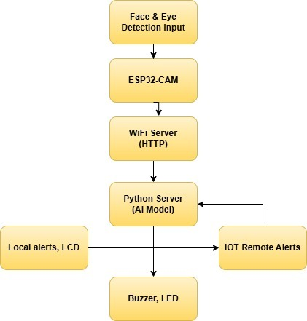

***Fig.1.Block Diagram Of Sleep Detection and Alert System for Drivers Using AI & IoT***

This Figure 1 shows a driver drowsiness detection system where the ESP32-CAM captures facial inputs, sends them via Wi-Fi to a Python AI server for analysis, and triggers local (buzzer, LCD) and IoT remote alerts based on detection.

**6. Circuit Diagram :**

**Working and Features of Circuit Diagram:**

**Figure 2 illustrates** a Drowsiness Detection and Alert System centered around the ESP32-CAM module, which continuously monitors the driver's facial features, especially eye movements, to detect signs of drowsiness. The ESP32-CAM is programmed using an FTDI programmer that connects to its TX and RX pins (IO3 and IO1), along with power and ground lines. Once programmed, the FTDI is removed for actual deployment. The system is powered through a 5V input and makes use of onboard GPIO pins to control alert mechanisms such as LEDs and a buzzer. A buzzer is connected to IO2 and emits a loud alert when drowsiness is detected, providing an immediate buzzing sound to regain the driver’s attention.

This system also includes a 16x2 I2C LCD, a buzzer, and LED lights. The LCD

 connects with SDA to IO14, SCL to I15, VCC to 5V, and GND to GND to display information using the I2C protocol.

Two LEDs green and red are used as visual indicators to display the driver’s status. The green LED, connected to IO4 via a 220-ohm resistor, remains ON when the driver is active and alert, indicating that the system is running normally and no drowsiness has been detected. Conversely, the red LED, connected to IO3 through another 220-ohm resistor, lights up when the system detects drowsiness, based on prolonged eye closure.

The ESP32-CAM continually captures video and processes it either on the device

 or through a server to detect conditions like drowsiness. When certain events are

 detected, the microcontroller activates the buzzer and LEDs and updates the LCD with messages. This ensures sound and light alerts make the system reliable and

effective for real-time monitoring of driver safety.

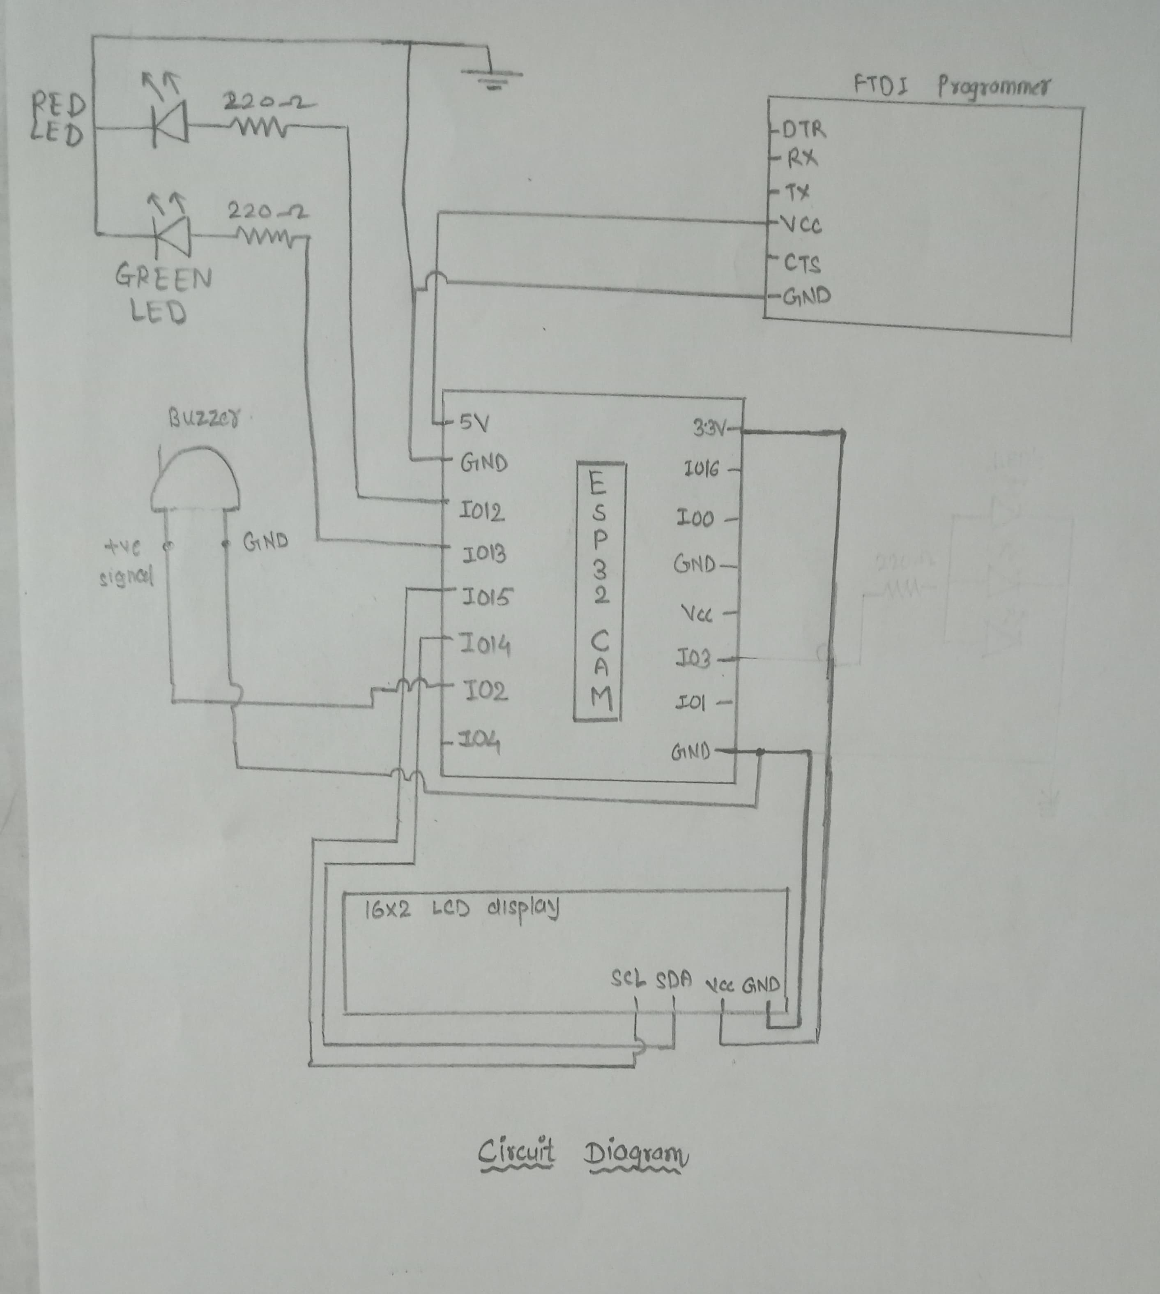

***Fig.2. Circuit Diagram Of Sleep Detection And Alert System For Drivers Using AI & IOT***

This **Figure 2 shows** a circuit diagram that connects an ESP32-CAM with a 16x2 LCD display (via I2C), two LEDs (red and green with 220Ω resistors), and a buzzer for local alerts. An FTDI programmer is used for uploading code to the ESP32-CAM. The components work together to provide visual and audio alerts based on drowsiness detection.**7. 1. Selection of components:**

1. ESP32-CAM Module :
   1. Purpose :  
       The ESP32-CAM is used for capturing real-time video and

facial landmark detection.

* 1. Key Features:
     + 1. 2MP camera (OV2640)
       2. Wi-Fi and Bluetooth support
       3. MicroSD card support for storage
       4. Low power consumption
  2. Datasheet & Features:
     + 1. ESP32-CAM features Wi-Fi and Bluetooth capabilities, ideal for real-time image streaming.
       2. Input Voltage**:** 5V
       3. Camera Module: OV2640
       4. Onboard Flash**:** 4MB (supports microSD card)
       5. GPIO Pins: Multiple GPIOs for sensor interfacing.
  3. Pin Diagram :

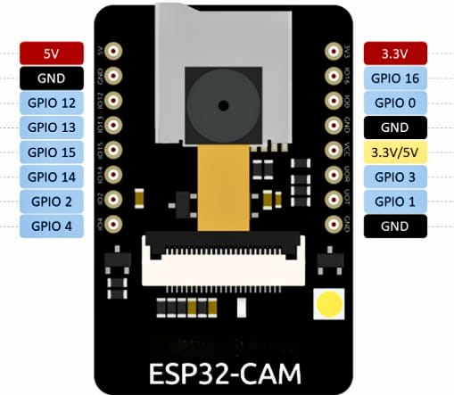

***Fig 3.ESP 32 – CAM***

This **Figure 3 shows** the pinout diagram of the ESP32-CAM module, highlighting GPIO pins, power pins (5V and 3.3V), and GND connections. It helps in identifying the correct pins for interfacing peripherals like sensors, LEDs, buzzers, and displays.

1. FTDI USB-to-TTL Converter :

a. Purpose : Used to program the ESP32-CAM module.

b. Key Features:

* + - * 1. USB to Serial communication
        2. Supports 3.3V and 5V systems

c. Datasheet & Features:

* + - 1. Operating Voltage: 5V or 3.3V
      2. Data Rate: 115200 baud rate (for programming)
      3. Supports UART, RX, TX for serial communication

d. Pin Diagram :

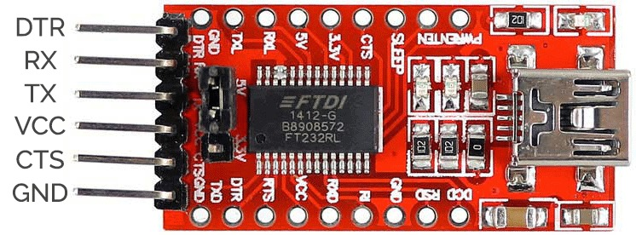

***Fig 4.*** ***FTDI MODULE***

This **Figure 4 shows** an FTDI programmer module used to upload code to microcontrollers like the ESP32-CAM via USB. It provides serial communication using TX, RX, and other control pins such as DTR, CTS, and VCC.

1. 16x2 LCD with I2C Module:  
   * 1. Purpose: Displays driver alert status or warning messages for the driver and surrounding vehicles.
     2. Key Features:
        1. Alphanumericdisplay**:** 16 characters x 2 lines.
        2. I2C interface: Uses only two data pins (SDA and SCL) to communicate.
        3. Adjustable backlight and contrast: Via onboard potentiometer.
        4. Low power consumption.
     3. Datasheet & Feature :

🔹 LCD Display Module (HD44780-based):

* + - * 1. Operating voltage: 5V
        2. Number of characters: 16 per row x 2 rows
        3. Character size: 5x8 dot matrix
        4. Display color: Usually green or blue backlight with white text
        5. Communication: Parallel (natively), adapted to I2C via backpack module
        6. Contrast control: Onboard potentiometer

🔹I2C Backpack Module (PCF8574 I/O Expander Chip):

* + - * 1. Operating voltage: 5V
        2. I2C address: Usually 0x27 or 0x3F (can be changed via jumpers)
        3. I2C speed: Standard 100kHz or Fast-mode 400kHz
        4. Built-in pull-up resistors on SDA/SCL lines
    1. Pin Diagram :

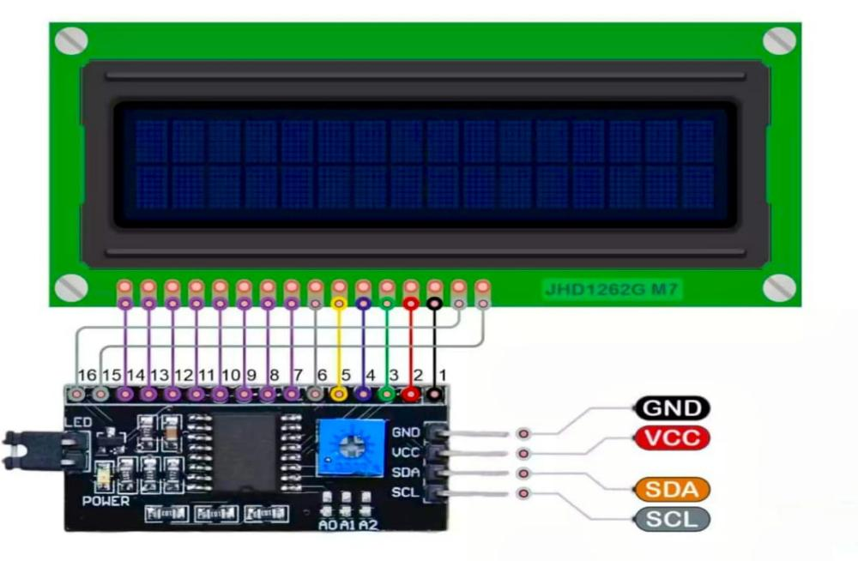

***Fig 5. LCD WITH I2C***

This **Figure 5 shows** a 16x2 LCD connected to an I2C module, which reduces wiring to just four pins: GND, VCC, SDA, and SCL. This setup is used for efficient display communication with microcontrollers like the ESP32-CAM.

1. Piezo Buzzer :
   1. Purpose : The buzzer is used to alert the user when

drowsiness is detected.

b. Key Features:

* + - 1. Loud and attention-catching sound.
      2. Operates on low voltage.
      3. Available in active (tone-ready) or passive (tone-controlled) types.

c. Datasheet & Features:

* + - 1. Operating Voltage: 3V to 5V DC
      2. Sound Output: ~85 dB at 10 cm
      3. Current Consumption: 10–35 mA

d. Pin Diagram :

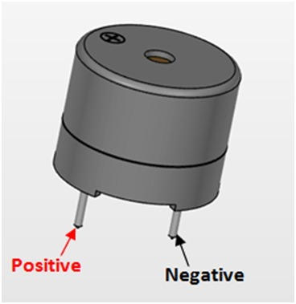

***Fig 6. Buzzer***

This **Figure 6 shows** a buzzer with two terminals: the longer pin is positive (+) and the shorter pin is negative (−). It is used for audio alerts in electronic circuits.

**5**. LED (Light Emitting Diode):

a. Purpose : Used as a visual indicator to alert the driver

or external observers of the driver’s status (e.g., blinking

on drowsiness).

* 1. Key Features:
     + 1. Emits visible light when powered
       2. Low power consumption
       3. Long lifespan
       4. Quick response time (lights up instantly)
       5. Different colors available (Red, Green, Blue, White, etc.)
       6. Requires current-limiting resistor (commonly 220Ω or 330Ω)

c. Datasheet & Features:

Polarity**:**

* + - * 1. **Anode (+):** Long leg – connect to positive via resistor
        2. **Cathode (–):** Short leg – connect to GND

d.Pin Diagram :

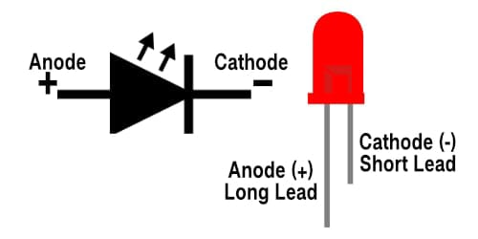

***Fig 7.LED***

This **Figure 7 shows** both the LED schematic symbol (with light‐emission arrows) and a physical LED, clearly marking the anode (+) as the long lead and the cathode (–) as the short lead.

**7.2.** **Calculation:**

**EAR (Eye Aspect Ratio):**

* + 1. The Eye Aspect Ratio (EAR) is a mathematical formula used to quantify the openness of the eye using specific facial landmarks. It is used to detect eye closure over time and thus, helps determine drowsiness.

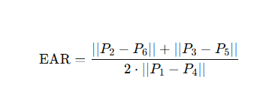

* + 1. P1​ to P6P_6P6​ are **6 key points around one eye** detected using **facial landmark detection** (usually from Dlib).
    2. ∣∣A−B∣∣||A - B||∣∣A−B∣∣ means the Euclidean distance between points A and B.
    3. EAR > 0.30 → Eyes open
    4. EAR < 0.30 for several consecutive frames (e.g., 15+ frames) → Likely Drowsy

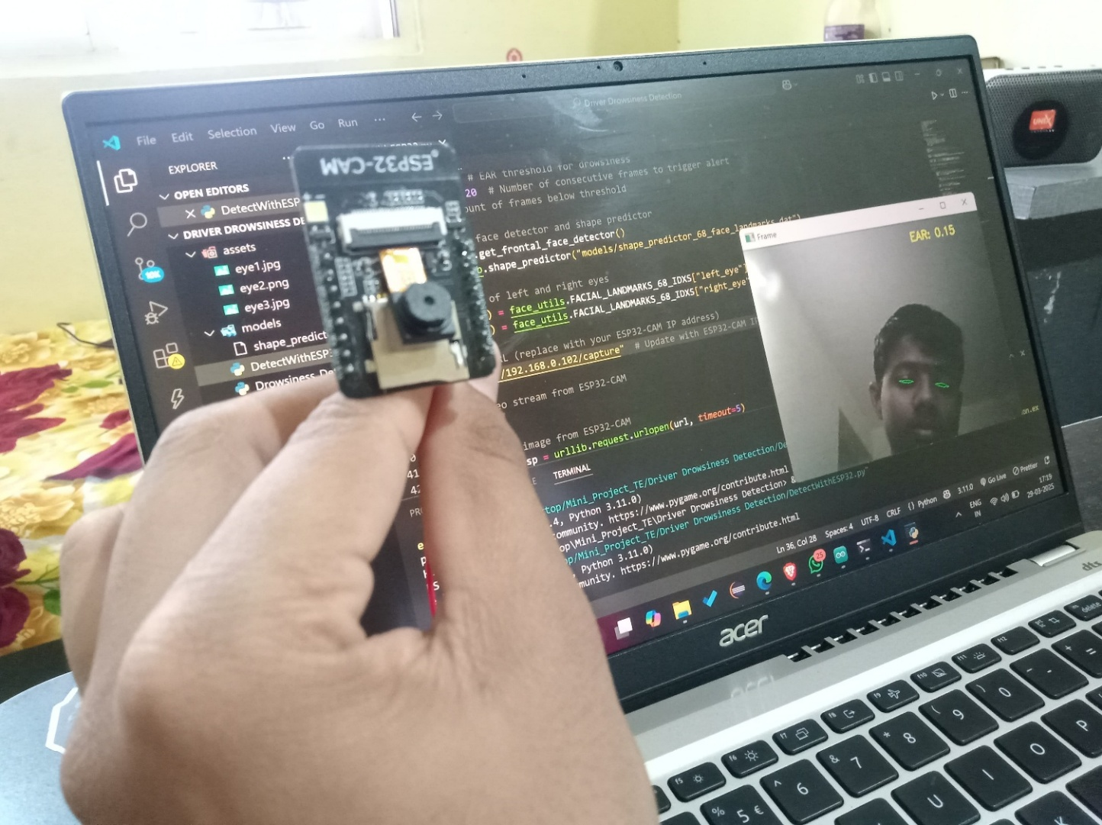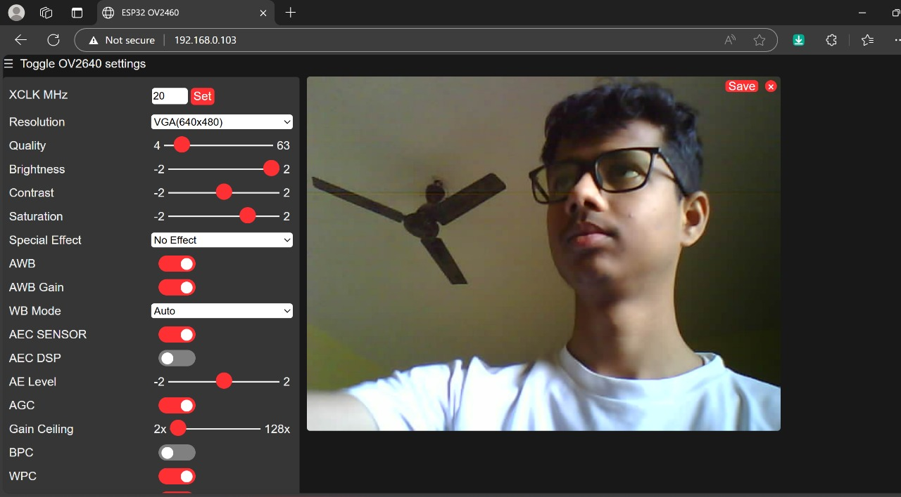**8. Simulation Results:**

***Fig 8.* *Simulation* *Results***

This **Figure 8 shows** a driver drowsiness detection system built around an ESP32-CAM module interfaced with a 16×2 I2C LCD for messages, two LEDs (red and green with 220 Ω resistors) for visual alerts, and a buzzer for audio alarms, with an FTDI programmer used to upload code. Development is done in **VS Code** using the PlatformIO extension, and the ESP32-CAM hosts a **lightweight web server**—accessible via its local-network IP (**“localhost”** on machine’s browser)—to **stream status and alert** information in real time.

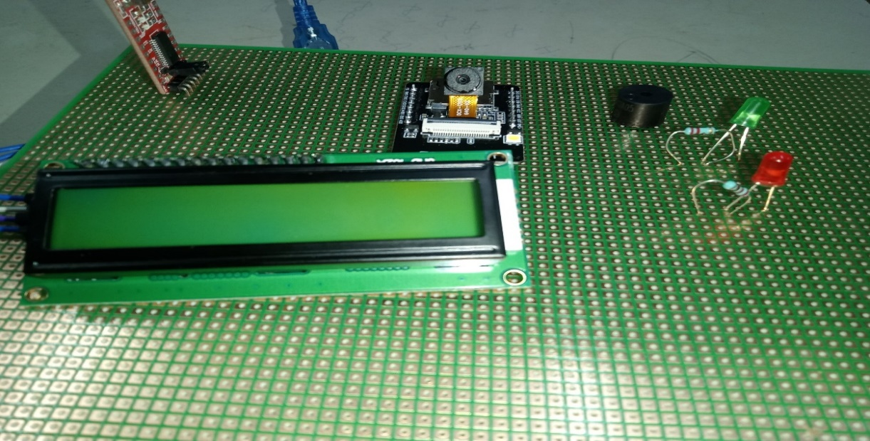**9. PCB Art Work:**

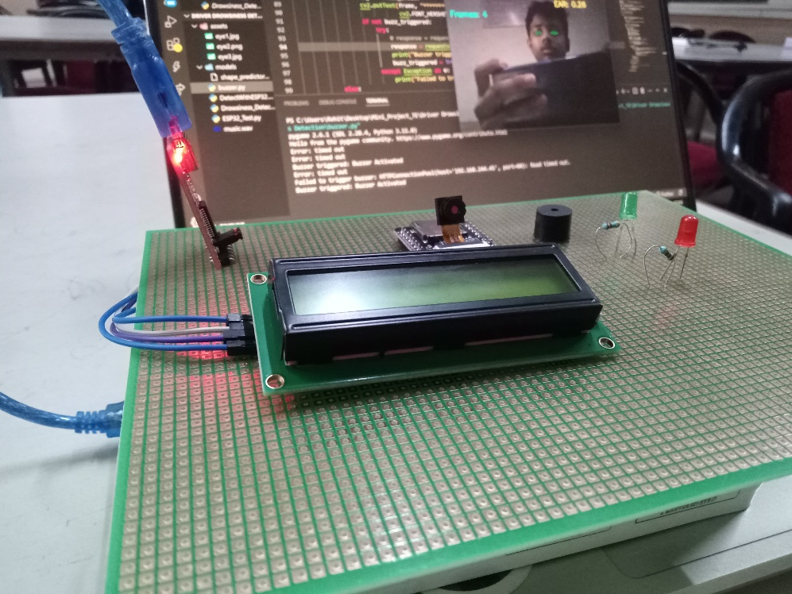

***Fig 9.PCB Results***

This **Figure 9 shows** PCB artwork is designed to neatly integrate all components of the drowsiness detection system, including the ESP32-CAM, I2C LCD, LEDs with resistors, buzzer, and power lines. It ensures **compact layout**, minimal interference, and **proper routing of power** and signal traces for stable performance and easy assembly.

**10. Testing Procedures:**

The testing process for this project had different steps to ensure it could detect

 drowsiness and send alerts in real time. First, each part of the system was tested to ensure they worked correctly. This included the ESP32-CAM, a buzzer, an

  LED, and an LCD display. We used simple code to make sure these hardware

 components were functioning properly.

Then, we tested the AI model. It detects facial landmarks and calculates the Eye Aspect Ratio (EAR). For this, we used a webcam in controlled light conditions to

fine-tune the accuracy in detecting drowsiness. After assembling all the parts, we tested the complete system in a simulated driving environment. This involved

checking its performance under various lighting conditions and different head positions to ensure the alerts were consistent. Finally, we tested the IoT features

by verifying the communication over HTTP between the Python backend and the

ESP32. This was to ensure that real-time alerts were correctly triggered and displayed whenever drowsiness was detected.

**11. Enclosure Design:**

**Front View :**

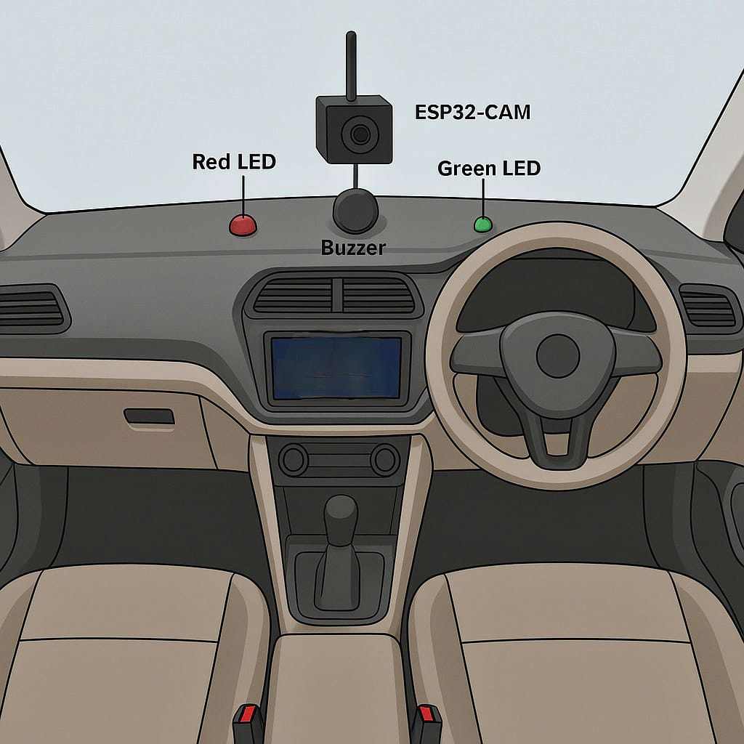

***Fig 10. front view of Enclosure Design***

This **Figure10 shows** the setup of a driver drowsiness detection system installed on a car's dashboard. At the center, an ESP32-CAM module is mounted to continuously monitor the driver’s face for signs of fatigue or drowsiness using AI-based image processing. Accompanying the camera, a red LED is placed to indicate when drowsiness is detected, while a green LED lights up when the driver is alert. A buzzer is also installed beside the camera, which sounds an alarm to immediately alert the driver if signs of drowsiness are observed. This compact setup ensures real-time monitoring and timely alerts to enhance road safety.

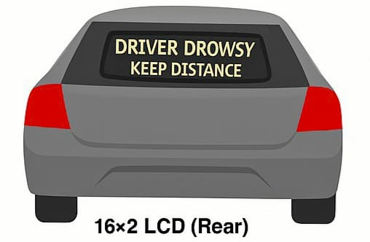

***Fig 11. rear view of Enclosure Design***

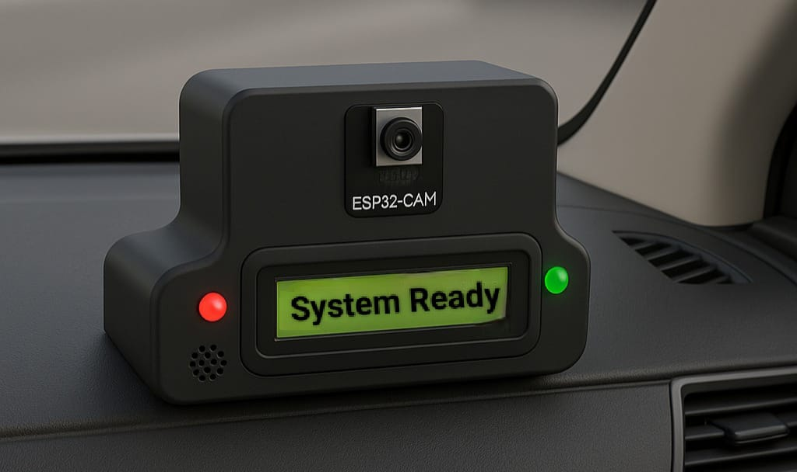The **Figure 11 shows** **the rear view of a car** equipped with a 16×2 LCD display installed on the rear windshield. The screen displays the message “DRIVER DROWSY – KEEP DISTANCE,” which alerts other vehicles behind the car to maintain a safe distance.

***Fig 12. Back view of Enclosure Design***

This **Figure 12 shows** the internal unit of the driver monitoring system mounted on a car dashboard, featuring an ESP32-CAM and a display indicating “System Ready.” LEDs and a buzzer provide visual and audio alerts to detect and respond to driver drowsiness in real time.

**12. Test Results:**

Test Results for Drowsiness Detection and Alert System

|  |  |  |  |  |  |  |  |  |  |  |  |  |  |  |  |  |  |  |  |  |
| --- | --- | --- | --- | --- | --- | --- | --- | --- | --- | --- | --- | --- | --- | --- | --- | --- | --- | --- | --- | --- |
| |  | | --- | | **Test Scenario** | | |  |  |  | | --- | --- | --- | | |  | | --- | | **Lighting Condition** |  |  | | --- | |  | | | |  |  |  | | --- | --- | --- | | |  | | --- | | **Driver State** |  |  | | --- | |  | | | |  | | --- | | **EAR Value** | | |  | | --- | | **Drowsiness Detected** |  |  | | --- | |  | | |  |  |  | | --- | --- | --- | | |  | | --- | | **Buzzer**  **/LCD Activated** |  |  | | --- | |  | | | |  | | --- | | **LCD Message Displayed** | |
| |  | | --- | | Normal (Eyes Open) |  |  | | --- | |  | | |  | | --- | | Bright Daylight |  |  | | --- | |  | | |  | | --- | | Awake |  |  | | --- | |  | | |  | | --- | | 0.32 |  |  | | --- | |  | | |  | | --- | | No |  |  | | --- | |  | | |  | | --- | | No |  |  | | --- | |  | | |  | | --- | | “Driver Active” |  |  | | --- | |  | |
| |  | | --- | | Long Blink  (3 sec) |  |  | | --- | |  | | |  | | --- | | Bright Daylight |  |  | | --- | |  | | Drowsy | 0.18 | Yes | Yes | |  | | --- | | “Drowsiness Detected” |  |  | | --- | |  | |
| |  | | --- | | Frequently Blinking |  |  | | --- | |  | | |  | | --- | | Dim Light |  |  | | --- | |  | | |  | | --- | | Slightly Drowsy |  |  | | --- | |  | | |  | | --- | | 0.22 |  |  | | --- | |  | | Yes | |  | | --- | | Yes |  |  | | --- | |  | | |  | | --- | | “Stay Alert” |  |  | | --- | |  | |
| |  | | --- | | Normal Driving (Head Slightly Turned) |  |  | | --- | |  | | |  | | --- | | Artificial Light |  |  | | --- | |  | | |  | | --- | | Awake |  |  | | --- | |  | | |  | | --- | | 0.30 |  |  | | --- | |  | | |  | | --- | | No |  |  | | --- | |  | | |  | | --- | | No |  |  | | --- | |  | | “Driver Active” |

***Table 1. Results Of Drowsiness Detection System***

This Table 1 Shows the Performance of the system at different lightning conditions.

**13. Conclusion :**

The "Sleep Detection and Alert System for Drivers Using AI and IoT" helps make

 roads safer by spotting when drivers are too sleepy. It uses AI to analyze the driv-er's face along with an ESP32-CAM and IoT features to send out quick sound and

visual warnings to wake the driver.

The system works well because it uses economical and easy-to-find parts, making

it practical to use in real-life situations. Tests show that it performs well in differ-

rent lights and with different head positions. This project tackles a big problem in

driving and shows that similar systems can be useful in healthcare, education, and

workplace safety. Overall, it helps create a driving experience that is safer, more

intelligent, and more alert.

**14. References :**

1. J. N, P. C, S. S, S. V, S. P. P and M. P. A, "An Improved Digital Image Processing Based Driver Sleep Identification and Alert System Using Internet of Things with Smart Sensors Association," 2024 Ninth International Conference on Science Technology Engineering and Mathematics (ICONSTEM), Chennai, India, 2024, pp. 1-7, doi: 10.1109/ICONSTEM60960.2024.10568610.

2. J. Purohit, V. Soni, A. Namdev, A. Mishra and S. Samal, "An Artificial Intelligence based Prototype of Drıver Drowsıness Detectıon for Intelligent Vehicles," *2023 IEEE World AI IoT Congress (AIIoT)*, Seattle, WA, USA, 2023, pp. 0633-0640, doi: 10.1109/AIIoT58121.2023.10174507.

3. J. Samadder, J. C. Das, D. Das, R. Sadhukhan and A. Parvin, "Smart IoT based Early Stage Drowsy Driver Detection Management System," *2022 IEEE International Conference of Electron Devices Society Kolkata Chapter (EDKCON)*, Kolkata, India, 2022, pp. 353-356, doi: 10.1109/EDKCON-

56221.2022.10032950.

4. D. Ojha, A. Pawar, G. Kasliwal, R. Raut and A. Devkar, "Driver Drowsiness Detection Using Deep Learning," 2023 4th International Conference for Emerging Technology (INCET), Belgaum, India, 2023, pp. 1-4, doi: 10.1109/-

INCET57972.2023.10169941.

5. A. B. Oommen, E. L. George, G. Reji, G. J. Sekhar and A. Antony, "Drowsiness Detection System," 2023 9th International Conference on Smart Computing and Communications (ICSCC), Kochi, Kerala, India, 2023, pp. 424-427, doi: 10.1109/ICSCC59169.2023.10334941.

6. T. K. Gannavaram V, R. Bejgam, S. B. Keshipeddi, A. Banda and G. Bollu, "Study of Automobile Safety Technology Development using Vehicular Safety Device (VSD)," *2021 6th International Conference on Inventive Computation Technologies (ICICT)*, Coimbatore, India, 2021, pp. 240-244, doi: 10.1109/ICICT50816.2021.9358670.

7. W. Deng and R. Wu, "Real-Time Driver-Drowsiness Detection System Using Facial Features," in IEEE Access, vol. 7, pp. 118727-118738, 2019, doi: 10.1109/ACCESS.2019.936663

8. T. M. Doan, M. H. Le, D. D. Nguyen and M. S. Nguyen, "Smart Desk in Hybrid Classroom: Research and Implement a System to detect Inattentive Students," *2022 International Conference on Advanced Computing and Analytics (ACOMPA)*, Ho Chi Minh City, Vietnam, 2022, pp. 60-65, doi: 10.1109/-

ACOMPA57018.2022.00016.

9. R. S. A. Fathima, K. V. Keerthi, K. N. Bhuvanesh, K. N. Jyothi, K. Sravya and P. V. Kumar, "Driver Drowsiness Detection System with OpenCV and Keras," *2024 International Conference on IoT Based Control Networks and Intelligent Systems (ICICNIS)*, Bengaluru, India, 2024, pp. 986-991, doi: 10.1109/ICICNIS64247.2024.10823233.

10. D. -L. Nguyen, M. D. Putro and K. -H. Jo, "Eyes Status Detector Based on Light-weight Convolutional Neural Networks supporting for Drowsiness Detection System," *IECON 2020 The 46th Annual Conference of the IEEE Industrial Electronics Society*, Singapore, 2020, pp. 477-482, doi: 10.1109/-IECON43393.2

020.9254858.